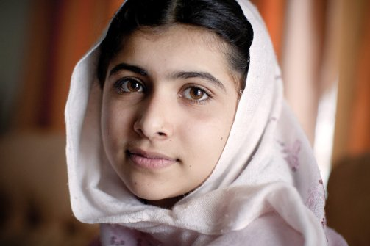

## Personal Reflections

Malala Yousafzai is Philosopher who really fought for what she believed in. And we can learn several things from her. One factor, is to give up on your beliefs and dreams. This is because we know that Malala had felt strongly about the restriction for her education and other girls in her village. But she did not give up, she fought for her rights, she wanted the right education for girls. It was certainly not acceptable for. Her actions have influenced ours. And we have learnt that you should not give on your beliefs. Also we can learn that you shouldn’t let anything get in our way. This shown, when Malala gets shot in the head, but she does not give up. One of her quotes states this ‘You can only shoot a body, they cannot shoot my dreams’. This is what is meant by not giving up. When she experienced being shot she says, that they can do that but they can’t shoot by dreams away.

## Achievements

Malala Yousafzai is a very inspiring person to look at when growing up. She has won a numerous amount of awards; from the Nobel Peace Prize in 2014 to the United Nations Prize in the Field of Human Rights in 2013. Malala has done many good things in life – from changing girls lives from across the world by giving themselves a right to education to showing people that speaking out and taking action will always get you somewhere and will do good for you. She has won the Nobel Peace Prize in 2014, the National Malala Peace Prize in 2011, the United Nations Prize in the Field of Human Rights in 2013, the Mother Teresa Awards in 2012, the Ambassador of Conscience Award in 2013 and many more…

Malala’s works have influenced many people – it has influenced the world. We can learn a lot from her beginning like standing up for ourselves and doing what is right. A girl who has been influenced by Malala is Anoyara Khatun from West Bengal in India. Anoyara Khatun learnt a variety of skills from Malala, and she made her voice heard after having many experiences with child exploitation. Like Malala she felt it was necessary to do something about this matter and she joined the Save the Children Multi-Activity Centre in her area to stop child exploitation. She has helped reunite 180 trafficked children with their families, prevented 35 child marriages, rescued 85 children from child labour and helped 200 children get registered into school.

## Personal Philosophy

Through Malala Yousafzai’s activism, to spread awareness for the need of girls to have access to education, she has taught, as one of her key teachings that gender inequality is not acceptable, and that women/girls should deserve a right to education. As one of, quotes stated that ‘Do remember one thing. Malala day is not my day. Today is the day of every women, every boy and every girl who raised their voices for their rights.’ From this we can work out that she not only teaches to raise our voices for our right for our education, but to raise our voices for our rights. Malala was influenced by her father, as he was the one who had saw the spark in her, who saw that she was a bright child. And when he knew this he had encouraged her to follow her dreams, and what she believed, no matter what got in her way. To always follow her beliefs. Without her father she would not have spoken out.

## Life

Inspiring, one word you can use to describe Malala. Malala Yousafzai was born on the 12th July 1997 in Mingora, Pakistan. She was the eldest child in her family, and had two younger brothers. Her family ran a chain of schools, which was founded by her father, Ziauddin Yousafzai, who was an education activist. He taught Malala English, Pashto and Urdu and as Malala attended one her father’s schools, her father had found out and sensed something special in Malala. And he encouraged her to express herself freely. Her hometown was rather exciting and busy, as it was a tourist attraction for summer festivals. But this had all changed when the Taliban came and tried to take control. At a young age, Malala Yousafzai felt girls should have a right towards education like boys and she defied the Taliban. In 2012, she was shot in the heat by a Taliban Gunman, and fortunately she is alive. In 2011, the BBC used Malala Yousafzai as a reporter in Afganistan for the war going on. Malala’s face was not shown on TV, but instead she done voice overs on the report and she told the BBC that she would not disclose her real name to the public but instead use the alias name Gul Makai. When she was 14, she found out that the Taliban had issued a death threat for her and her family thought the Taliban would not hurt a child, but behind closed doors something bad happened. When Malala was travelling home by bus from school, there was a Taliban gunman on board. This gunman demanded to know where Malala was and her friends gave away where she is – they began making eye contact with her. The gunman shot an innocent girl on the head on the 9th October 2012.

**Malala Yousafzai**