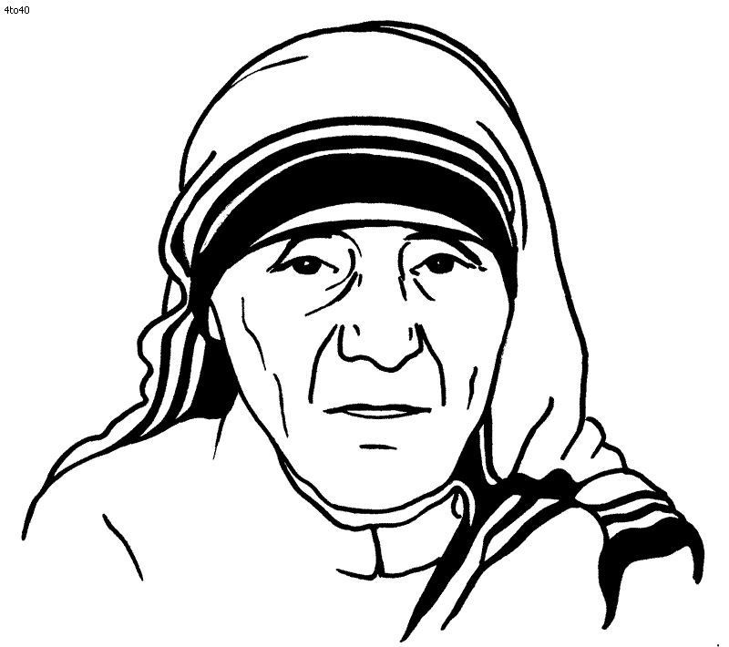

## Similarities between Mother Teresa and

## Malala Yousafzai

There are many similarities between Malala Yousafzai and Mother Teresa. For example they both fought for equality and education between people. Also the fact that they both are truly remarkable. The differences between them are that Malala Yousef did what she did naturally whereas Mother Teresa was told to do so.

## Achievements

Prominent religious figure, saint and nun Mother Teresa, provided physical and emotional support to hundreds of homeless and sick individuals; she received numerous awards and honours for her efforts, including the gold medal of the Soviet Union's Peace Committee. She also awarded the Nobel Peace prize in 1979 for contributing to our society by putting others before her. It is evident when she struggles to help diminish poverty.

**Personal Philosophy & Personal Reflections**

We can learn a lot form Mother Teresa. For example treat people the way you want to be treated or even believe and God will do the rest. Also we can learn to never give up. There is a clear example of this when her father died and she became alone and scared ,but, instead of giving up she got back up. I was traveling to Darjeeling by train, when I heard the voice of God, he told me do stop what I am doing and to help people. It was that day which inspired Mother Teresa to help people and be the person she was. Her faith in humanity was far greater than anyone alive. She was a saviour. I was traveling to Darjeeling by train, when I heard the voice of God, he told me do stop what I am doing and to help people. It was that day which inspired Mother Teresa to help people and be the person she was. Her faith in humanity was far greater than anyone alive. She was a saviour.

**Life**

Mother Teresa was born on the 26th of August 1910. She was baptised the next day in a local church. She was born to an entrepreneur and to a church volunteer. Her mother was extremely religious and she frequently told Mother Teresa stories about their religion and how you should give to others and follow God. This was key factor in her life as she devoted her life to her religion and tov the sick and poor. In 1919, when Mother Teresa was only 8 years old, her father suddenly fell ill and died. No one knows why he had died but the outcome of this was that Mother Teresa became extremely bonded to her mother. Her mother taught to never eat a single mouthful unless you are sharing it with others. This quote stayed with Mother Teresa and made her who she was. A while later left to India to teach. She spent the next 17 years of her life in India and it was there that she decided to devote her life to the poor. Afterward she was sent to Calcutta, where she was assigned to teach at Saint Mary's High School for Girls, a school run by the Loreto Sisters and dedicated to teaching girls from the city's poorest Bengali families. From that day forth she tried her best to help others. After several years of deteriorating health in which she suffered from heart, lung and kidney problems, Mother Teresa died on September 5, 1997 at the age of 87. Her legacy to help others still lives on in many.

**Mother Teresa**